Eagle Creek Sailing Club
For Sale Items

William H Yost (Social Member of EC)
317-446-4661
yostwh@gmail.com

Tiller Auto Pilot - Ray Marine Model: ST2000+ Brand New in the Box $350.00 Each
Qty of 2 Available.
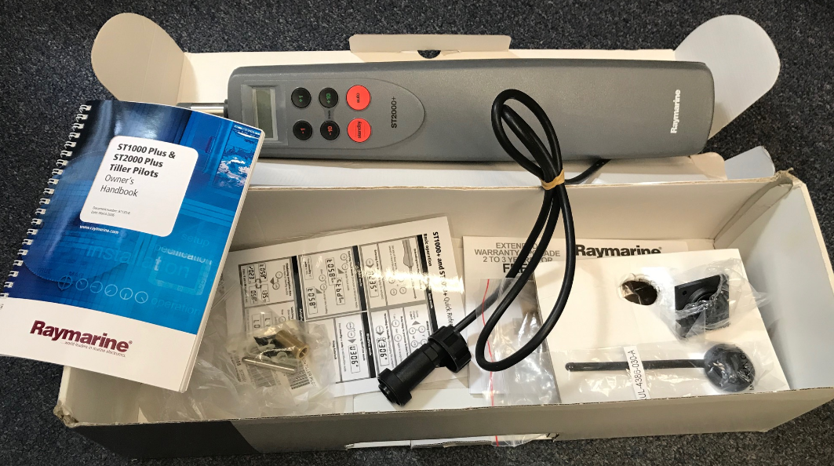

135 Genoa (Schurr) Sail for an S27.3 Lightly Used
Main Sail (Schurr) for an S27.3 Lightly Used $500 for the pair 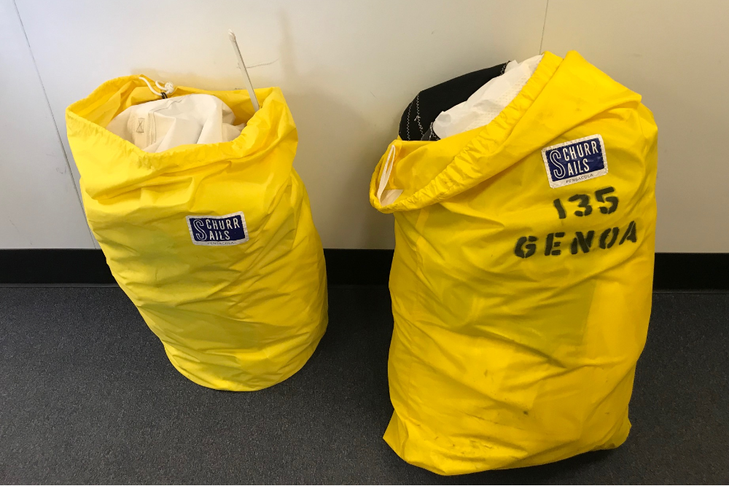

28 foot Spinnaker Sleeve BRAND New Still in Bag - Gray $100.00
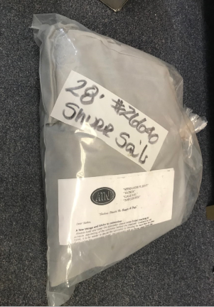
Bimini (Sunbrella, Color Black) BRAND NEW STILL IN BOX for an S2 or Catalina 25 With Window – $500.00
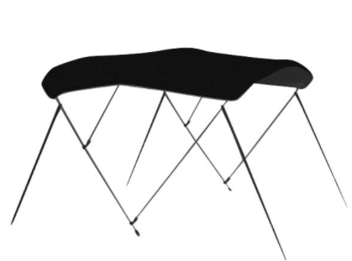

Bimini (Sunbrella, Color Royal Blue) BRAND NEW STILL IN BOX for an S2 or Catalina 25– $250.00
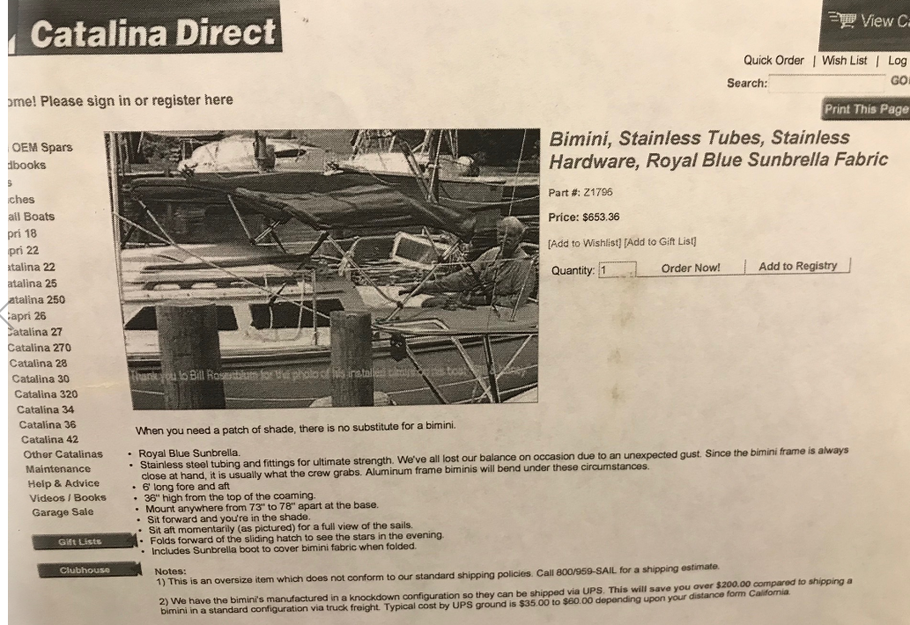
Bimini (Sunbrella, Color Black) Lightly Used assembled for an
S2 or Catalina 25– $400
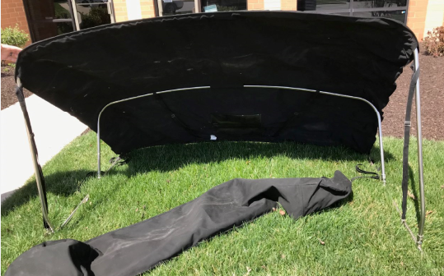
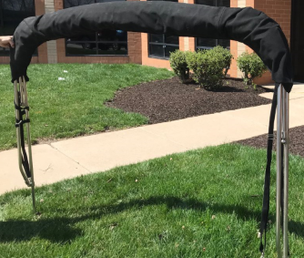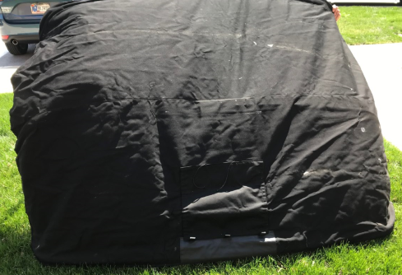

Heavy Duty Garelick Motor Mount Brand New - $350.00
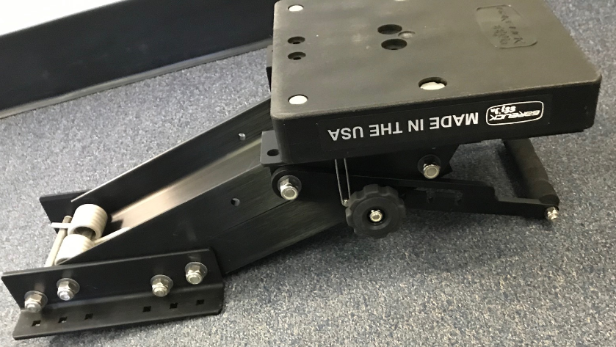
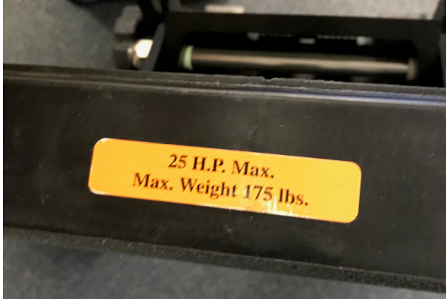
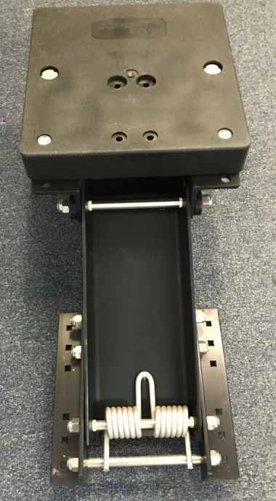

Traditional 13 lbs Fluke Anchor (Danforth) USED $50.00
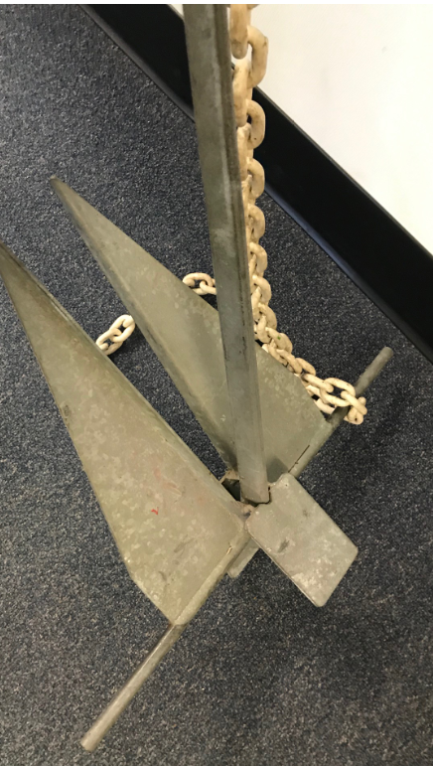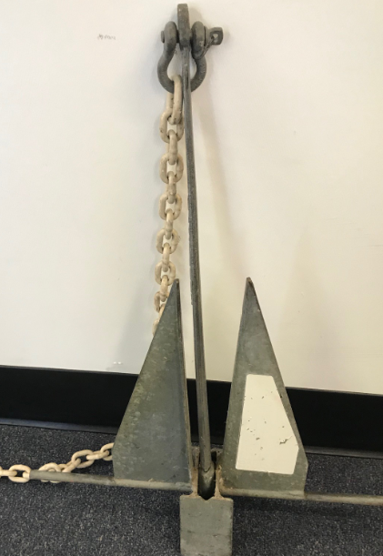

Winch for Boat Trailer- USED $ 35.00
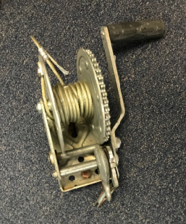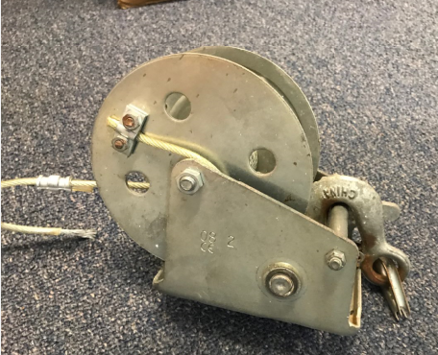

Winch for Boat Trailer- BRAND NEW $ 100.00

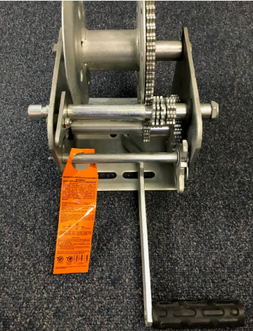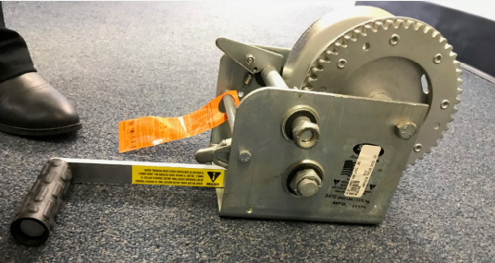

Lewmar 6C Winch Chrome Single-Speed Model# 1906100
BRAND NEW IN UNOPENED BOX $100 Each (Qty of 2 Available) To buy it new now $177

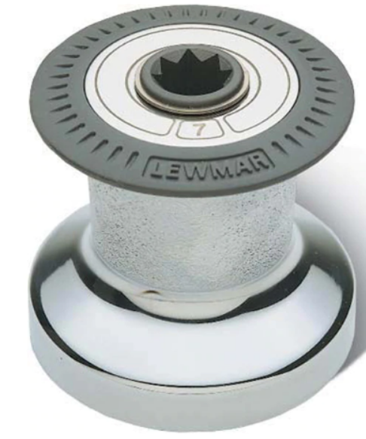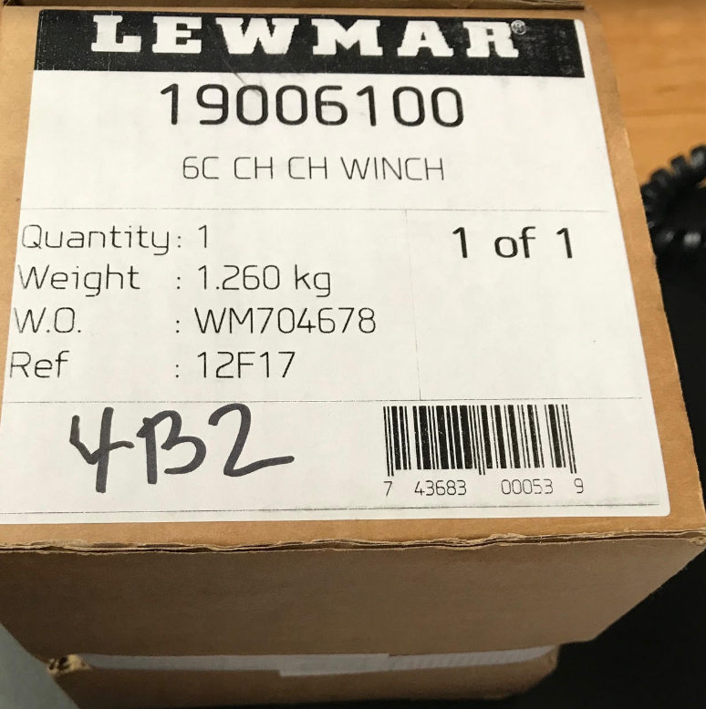

SolarLand (BRAND NEW IN BOX) W/Deck Connector - Model #SLP010-12U 10 Watts, 12
Volts $35.00
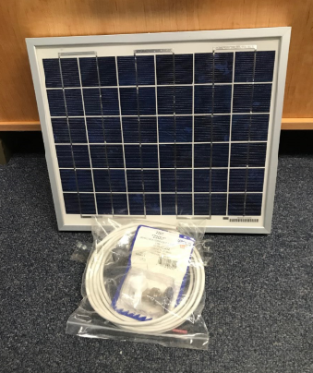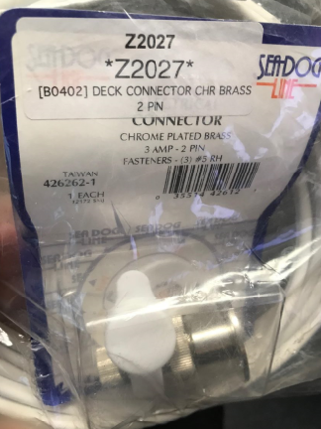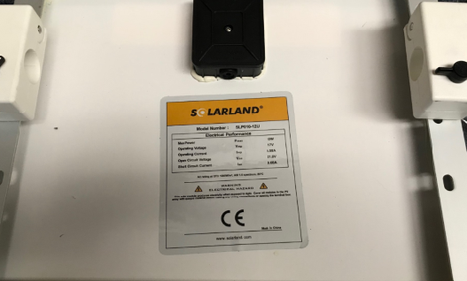

CP-22 MK ll Kick-up Uni-Foil Rudder w/Pintles & Tiller (BRAND NEW STILL IN BOX)
$400 (To buy it new now $897.00)
